Certificate in Information Technology

Practical Lab 6 – Disk Management, O.S. Installs

Student Names: Jayden Caldwell

Lab Instructions:

You are required to install two different operating systems on a single PC
- Boot up the computer kit and record below the size of the primary hard drive.

Size of Hard Drive: 500GB

- Install Windows 7 onto a partition that takes up 50% of the drive space.

Once Windows 7 is installed, open the Disk Management Console and take a screen shot of the partition setup. Save the screen shot onto a USB Device. Insert the screen shot in this document, below this step.

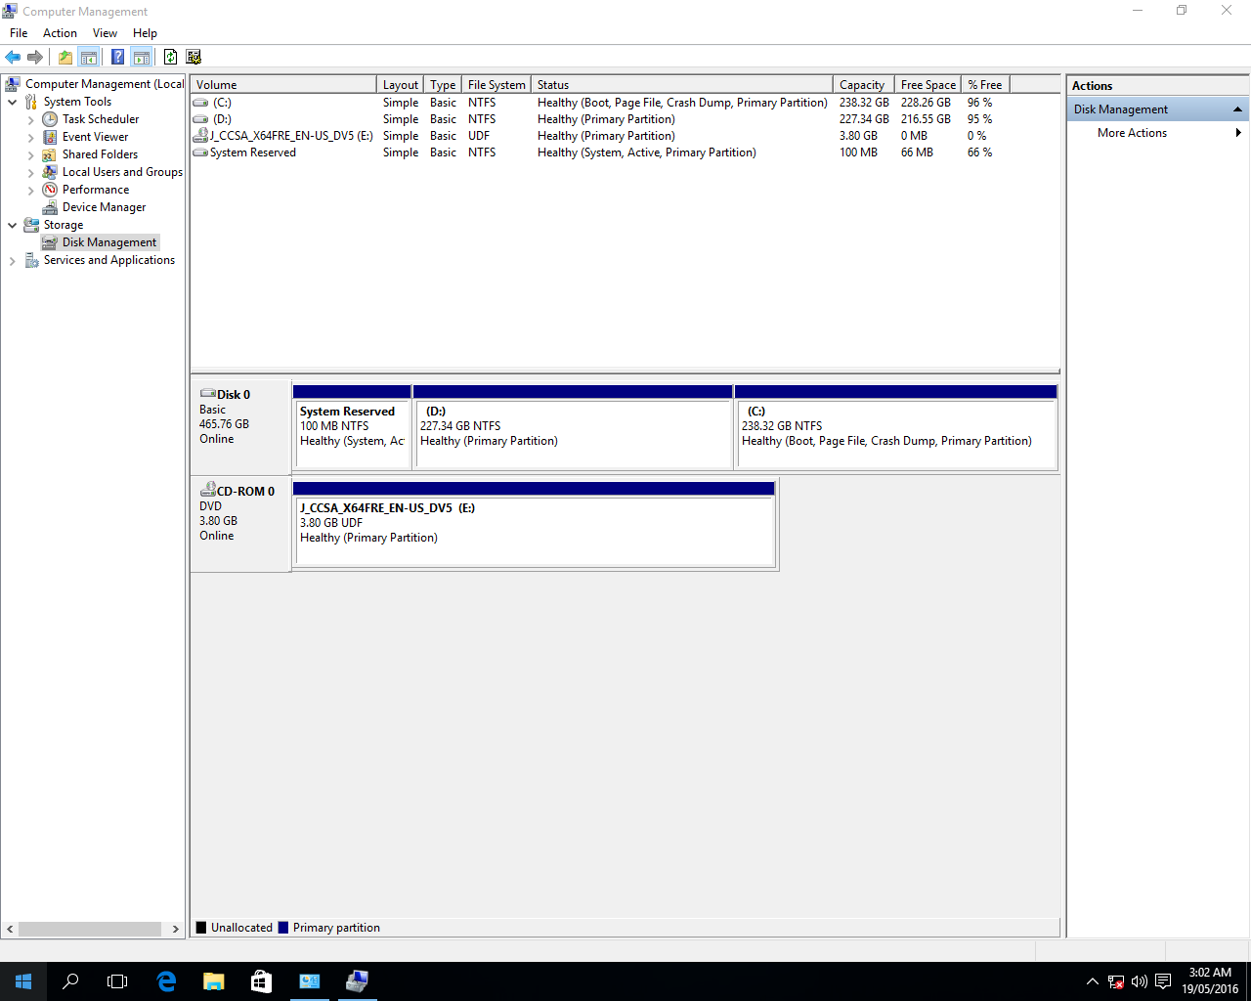
- Install Windows 10 or Ubuntu onto a partition that takes up the rest of the drive space.
- While it is installing, complete some research using the Internet, on five advantages of Windows 10 over Windows 7. In your own words list these reasons in the spaces below, making sure that you explain why each reason is an advantage.
- Cortana is a great edition to windows 10 if you need to know anything about Windows 10 just ask. Cortana can do a range of different things on your computer.
- Windows 10 runs a lot smoother than windows 7 does which makes it a lot nicer to use and everything else is just a bit sharper and faster.
- Windows 10 built in antivirus is a great feature because it provides security and windows 7 did not have a built in Antivirus
- Direct X12 is a massive advantage for gamers, this will make your games run smoother and faster on the system
- The free upgrade for users that already have windows 7 or 8 is a great feature so everyone can have the latest OS.

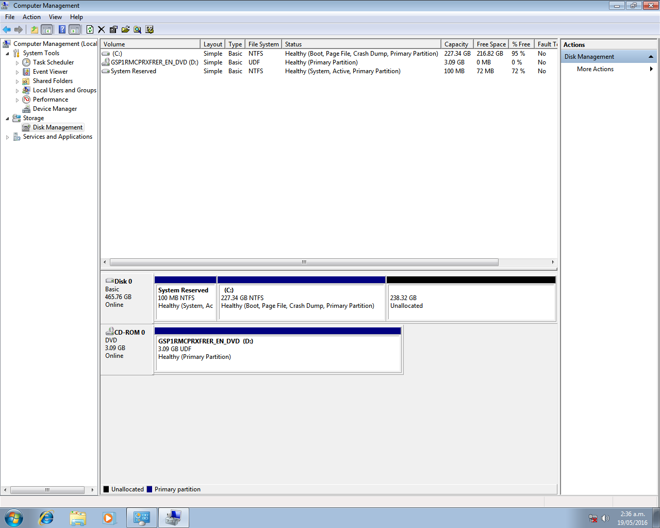
- Once the second OS is installed, open the Disk Management Console and take a screen shot of the partition setup. Save the screen shot onto a USB Device. Insert the screen shot in this document, below this step. We decided to install windows 10.
- Demonstrate to the lecturer that you can now boot into either operating system on the computer.
- Submit a copy of this lab sheet onto Moodle. You should have been shown how to do this. If you are unsure then ask your lecturer.

Remember:-
- You will need to complete a journal entry for this lab.

